Department of Computing

CS 330: Operating Systems
BESE-11AB
Lab 6: File Management

Date: 21 Oct 2022
Time: 02:00 PM-05:00 PM
Instructor: Engr. Taufiq ur Rehman
Lab Engineer: Maham Daoud

Submitted By | CMS ID
Syeda Fatima Shahid | 337346
Hafsa Malik | 341303

SYSTEM DESIGN:-
Directory and File Implementation
For the directory implementation, we have made use of Single-level directory structure as it is easy to understand and allows for a more readable code. Single level directory structure supports single-user file management. Each file is contained in its respective directory which belongs to a single user. File operations can be implemented with flexibility and ease with single-level directory structure. Below is visual representation of single-level directory structure:
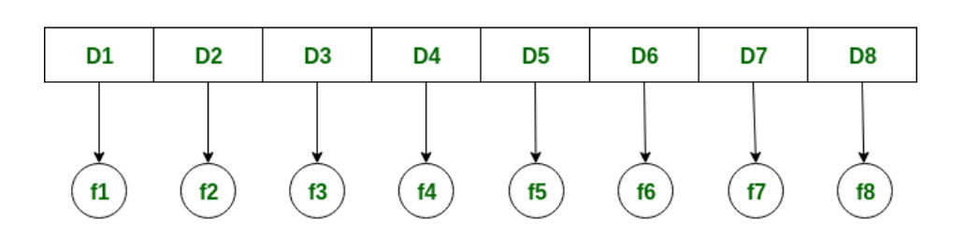
For the file implementation, we made use of Pickle and JSON format. The pickle module is used to serialize and de-serialize python objects. We used it in our program to pickle the file object and save it to disk. Pickle serializes the object first and then writes it to disk. It is a way to convert any python object (list, dict, file etc) into a stream of characters. This character stream contains all the necessary information for reconstructing the object in another python script. Below is a visual representation of Pickle operations:
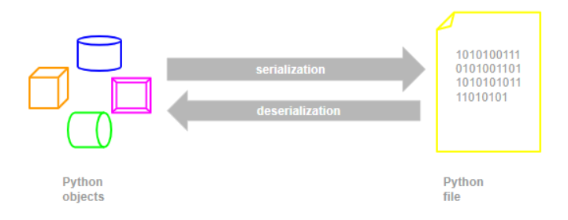
Moreover, JSON has been used in the program to write dictionary (discussed later) into a file. JSON is a standard text-based format for representing structured data. JSON can be used as a data format for any programming language to provide a high level of interoperability. We imported JSON in our program and created a dictionary alongside. The dictionary that contained the directory structure was converted into string format using JSON dumps and it was written to a file.

References:
- https://www.w3schools.com/whatis/whatis_json.asp
- https://www.javatpoint.com/os-single-level-directory
- https://programingmanual.blogspot.com/2018/02/write-c-program-to-simulate-single.html
- https://stackoverflow.com/questions/11218477/how-can-i-use-pickle-to-save-a-dict-or-any-other-python-object

